AI-Based Credit Risk Assessment System

PROJECT DISSERTATION
Submitted in partial fulfillment of the requirements
for the award of the degree of

Bachelor of Technology
in
Artificial Intelligence and Machine Learning

Submitted By
Name : Omni Sharma
Registration Number : 23BAI10207
Application no.- IN26015012
Batch Code – 13 A

Project Supervisor
Guide Name : Puneet Gurbani

Department of Computer Science and Engineering
VIT Bhopal University

Submission Month & Year : July 2026

Abstract

This project focuses on developing an AI-Based Credit Risk Assessment System that predicts the credit risk of loan applicants using machine learning. A Random Forest Classifier is employed to analyze applicant information and categorize individuals into Low Credit Risk or High Credit Risk groups. The prediction is based on various financial and personal attributes, including applicant income, co-applicant income, loan amount, loan term, credit history, education level, employment status, and property location.
To improve the reliability of the model, the dataset is first preprocessed by handling missing values, converting categorical data into numerical form, scaling numerical features, and creating additional financial attributes through feature engineering. The trained machine learning model is then deployed using Streamlit, providing an interactive web-based interface where users can enter applicant details and instantly receive a credit risk assessment, confidence score, and recommendation.
The proposed system offers a fast, consistent, and data-driven approach for preliminary credit evaluation. It demonstrates how machine learning can assist financial institutions in supporting loan assessment processes, reducing manual effort, and improving the efficiency of credit risk analysis.

Introduction

The banking and financial industry relies heavily on accurate credit evaluation to make informed loan approval decisions and reduce the possibility of financial losses. Before granting a loan, banks analyze several applicant-related factors such as income, employment status, credit history, education, loan amount, and repayment capability to determine the applicant's financial reliability. Traditionally, this assessment is carried out manually, which can be time-consuming, require significant human effort, and may result in inconsistent decisions.
With the growth of Artificial Intelligence (AI) and Machine Learning (ML), financial institutions can improve this process by automating preliminary credit assessments. Machine learning models are capable of learning patterns from historical loan application data and identifying relationships between applicant characteristics and loan outcomes. Based on these learned patterns, the system can estimate the credit risk of new applicants with greater speed and consistency. By supporting data-driven decision-making, machine learning helps financial institutions streamline the loan evaluation process, reduce manual workload, and improve the overall efficiency and reliability of credit risk assessment.

Problem Statement

The traditional process of evaluating loan applications is often slow, labor-intensive, and may result in inconsistent decisions due to manual assessment. Financial institutions need an efficient and reliable solution that can support the preliminary evaluation of loan applicants. This project aims to develop a Machine Learning-based Credit Risk Assessment System that utilizes historical loan application data to classify applicants into Low Credit Risk or High Credit Risk categories. The proposed system is designed to provide faster, more accurate, and consistent credit risk predictions, thereby assisting financial institutions in improving the efficiency of the loan evaluation process.

Objectives

- To develop an AI-based Credit Risk Assessment System capable of predicting the credit risk level of loan applicants using machine learning techniques.
- To collect, clean, and preprocess the loan application dataset by handling missing values, encoding categorical variables, and scaling numerical features.
- To perform feature engineering by creating additional financial attributes, such as Total Income, Loan Income Ratio, and Estimated EMI, to improve prediction accuracy.
- To train and evaluate a Random Forest Classifier using historical loan data and assess its performance using accuracy and other evaluation metrics.
- To build an interactive web application using Streamlit that allows users to enter applicant details and receive real-time credit risk predictions along with confidence scores.

Dataset

The project uses the Loan Prediction dataset, which contains historical information about loan applicants and their loan approval status. Each record represents an individual applicant and includes demographic, financial, and loan-related attributes that influence credit assessment. The dataset consists of features such as Gender, Marital Status, Number of Dependents, Education Level, Self-Employment Status, Applicant Income, Co-applicant Income, Loan Amount, Loan Amount Term, Credit History, Property Area, and the target variable, Loan Status. This dataset provides the necessary information to train and evaluate a machine learning model capable of identifying patterns associated with credit risk and predicting whether a new applicant falls into the Low Credit Risk or High Credit Risk category.

Data Preprocessing

- Loaded the loan prediction dataset using the Pandas library.
- Identified and analyzed missing values present in the dataset.
- Replaced missing values in categorical features (such as Gender, Married, Dependents, and Self-Employed) using the mode of each column.
- Filled missing values in numerical features (such as Loan Amount and Loan Amount Term) using the median to maintain data consistency.
- Converted categorical variables into numerical values using LabelEncoder, making them suitable for machine learning algorithms.
- Standardized numerical features using StandardScaler to ensure all features have a similar scale and improve model performance.
- Verified that all missing values were successfully handled after preprocessing.
- Saved the cleaned and preprocessed dataset as cleaned_train.csv for further feature engineering, model training, and evaluation.

Feature Engineering
To improve the predictive performance of the machine learning model, additional features were created from the existing dataset:
- Total Income: Calculated by adding the applicant's income and the co-applicant's income. This feature represents the combined earning capacity of the applicant's household.
Formula:
TotalIncome = ApplicantIncome + CoapplicantIncome
- Loan Income Ratio: Computed by dividing the loan amount by the total income. This feature estimates the applicant's repayment burden relative to their available income.
Formula:
LoanIncomeRatio = LoanAmount / TotalIncome
- Estimated EMI (Equated Monthly Installment): Calculated by dividing the loan amount by the loan repayment term. This provides an approximate estimate of the monthly repayment obligation.
Formula:
EstimatedEMI = LoanAmount / Loan_Amount_Term
- These engineered features provide additional financial insights that are not directly available in the original dataset and help the Random Forest model make more accurate credit risk predictions by better representing the applicant's repayment capacity and financial profile.

Model

- The preprocessed dataset was divided into training and testing sets using an 80:20 train-test split, where 80% of the data was used for training the model and the remaining 20% was reserved for performance evaluation.
- A Random Forest Classifier was selected as the machine learning algorithm due to its high accuracy, robustness, and ability to handle both numerical and categorical features effectively.
- The model was trained using the processed dataset along with the engineered features to learn patterns associated with credit risk.
- After training, the model's performance was evaluated using accuracy, confusion matrix, and classification report to measure its prediction capability.
- The trained Random Forest model achieved an accuracy of approximately 78.86% on the testing dataset.
- Finally, the trained model (credit_model.pkl), label encoders (label_encoders.pkl), and feature scaler (scaler.pkl) were saved using the Joblib library, enabling the model to be loaded later for real-time predictions in the Streamlit web application.

System Implementation
The developed application provides an interactive web interface built using Streamlit. Users can enter the required applicant details such as gender, marital status, income, loan amount, loan repayment term, education, employment status, credit history, and property area. Once the required information is entered, the application processes the data using the same preprocessing techniques applied during model training and predicts whether the applicant belongs to the Low Credit Risk or High Credit Risk category. The application also displays the confidence score and a summary of the entered information

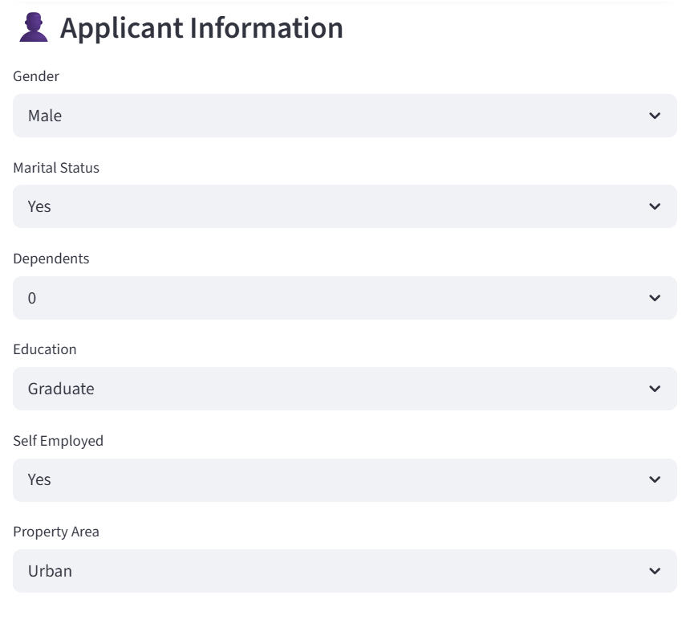
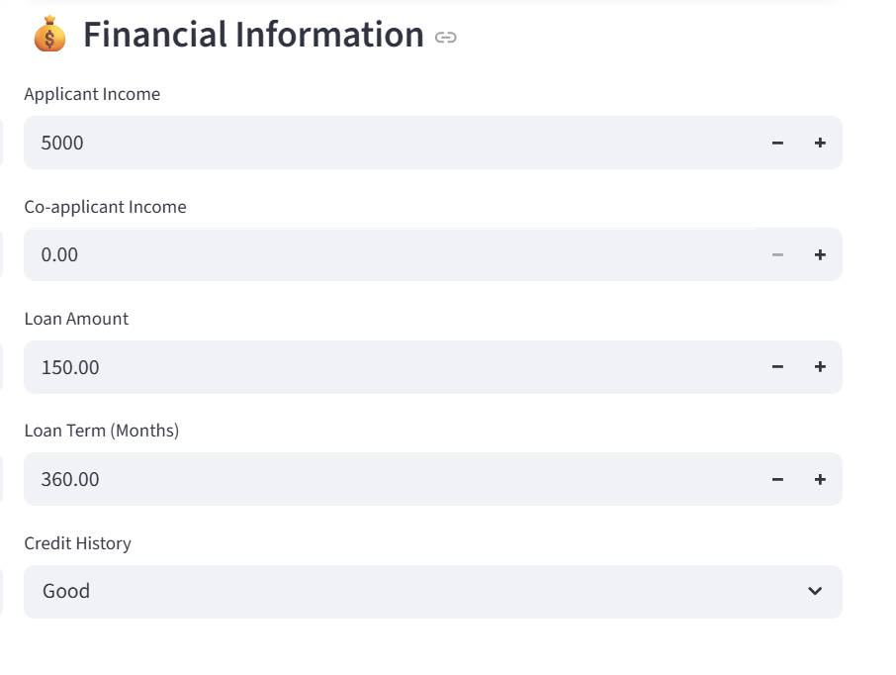
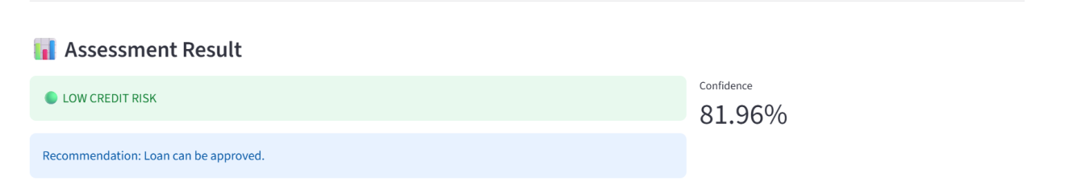
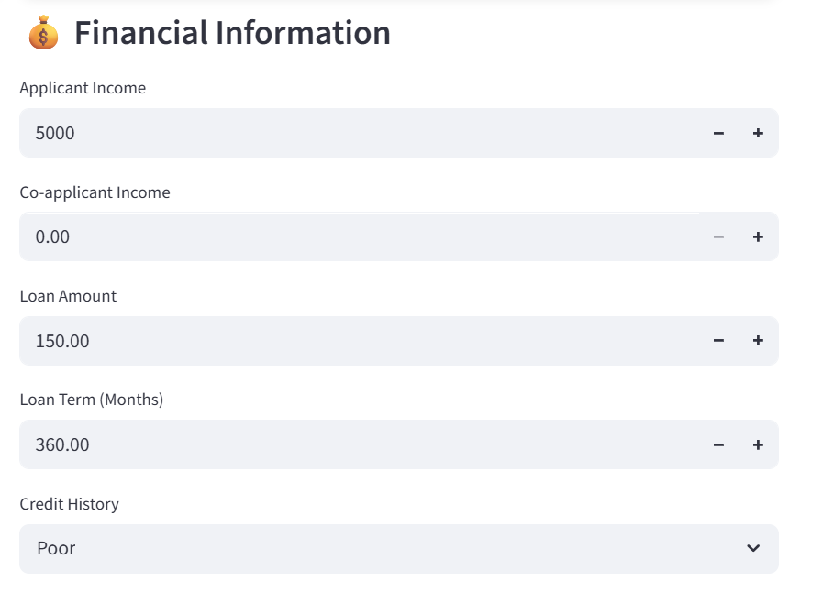
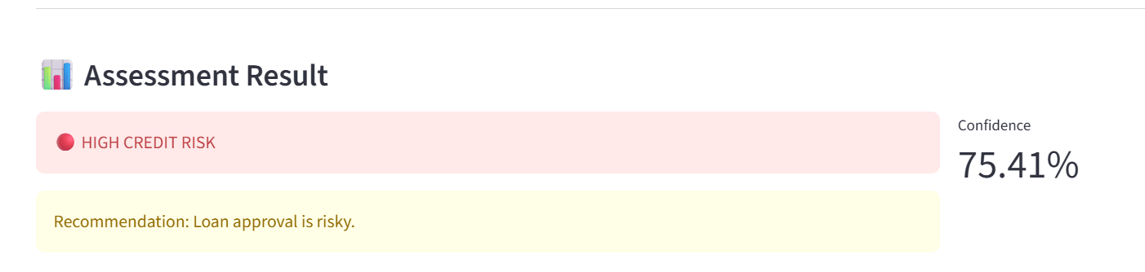

Results

- The trained Random Forest Classifier achieved an accuracy of approximately 78.86% on the testing dataset, demonstrating its ability to effectively classify loan applicants into different credit risk categories.
- Model performance was evaluated using multiple evaluation metrics, including Accuracy, Confusion Matrix, and Classification Report, to assess the quality of predictions.
- The trained model was successfully integrated into a Streamlit web application, enabling real-time credit risk assessment through an interactive user interface.
- Users can enter applicant details such as income, loan amount, credit history, education, employment status, and property area to receive an instant prediction.
- The application classifies applicants into Low Credit Risk or High Credit Risk categories and displays a confidence score indicating the model's confidence in its prediction.
- The developed system provides a simple, fast, and user-friendly solution for preliminary credit risk assessment, demonstrating the practical application of machine learning in the banking and finance domain.

Deployment

- The trained Random Forest model was successfully integrated into a Streamlit web application to enable real-time credit risk prediction.
- The application provides a simple and interactive user interface where users can enter applicant details such as income, loan amount, credit history, education, employment status, and property area.
- User inputs are automatically preprocessed using the saved Label Encoders and StandardScaler before being passed to the trained machine learning model.
- The application predicts whether the applicant falls into the Low Credit Risk or High Credit Risk category and displays the prediction along with a confidence score.
- The deployment demonstrates how a trained machine learning model can be converted into a practical and user-friendly decision-support application for preliminary credit risk assessment.
- The application is designed to provide fast, reliable, and real-time predictions, making it suitable for demonstrating the practical implementation of machine learning in the banking and finance domain.

Advantages

- Fast Predictions: The trained machine learning model generates credit risk predictions within seconds, significantly reducing the time required for preliminary loan assessment.
- User-Friendly Interface: The Streamlit-based web application provides a simple, interactive, and easy-to-use interface, allowing users to enter applicant details and obtain predictions without requiring technical expertise.
- Reduced Manual Effort: The system automates the initial credit risk evaluation process, minimizing manual analysis and helping financial institutions save time and resources.
- Reusable Trained Model: The trained Random Forest model, along with the preprocessing components, is saved using Joblib, enabling it to be reused for future predictions without retraining.
- Consistent Decision Support: The model evaluates every applicant using the same learned patterns from historical data, providing consistent and unbiased preliminary risk assessments.
- Scalable Solution: The application can be extended with larger datasets, additional financial features, or integrated into existing banking systems for broader real-world use.
- Educational and Practical Value: The project demonstrates the complete machine learning workflow—from data preprocessing and model training to deployment—making it a valuable educational project as well as a foundation for real-world financial applications.

Limitations

- Dependence on Dataset Quality: The accuracy and reliability of the model largely depend on the quality, size, and representativeness of the training dataset. Incomplete or biased data may affect prediction performance.
- Limited Features: The model uses only the attributes available in the dataset. Other important financial factors, such as credit score, outstanding debts, employment history, or banking transactions, are not considered.
- Prediction Accuracy: Although the model achieved an accuracy of approximately 78.86%, it may still produce incorrect predictions for certain applicants due to the complexity of real-world financial behavior.
- Static Model: The current model is trained on a fixed dataset and does not automatically learn from new loan applications or changing financial trends unless it is retrained.
- Decision Support Tool: The application is intended to assist in preliminary credit risk assessment and should be used as a decision-support system rather than a replacement for professional financial analysis and human judgment.
- Limited Real-World Validation: The project has been developed using a publicly available dataset for educational purposes and has not been validated using real-world banking data or production environments.

Future Scope

- Integration with Real Banking Systems: The application can be integrated with banking databases and loan management systems to support real-world credit risk assessment.
- Use of Larger and Diverse Datasets: Training the model on larger and more diverse datasets can improve prediction accuracy and make the system more robust.
- Implementation of Explainable AI (XAI): Techniques such as SHAP or LIME can be incorporated to provide detailed explanations for each prediction, improving transparency and user trust.
- Comparison with Other Machine Learning Models: Future work can include evaluating algorithms such as XGBoost, LightGBM, Support Vector Machine (SVM), and Neural Networks to identify the most effective model for credit risk prediction.
- Cloud-Based Deployment: The application can be deployed on cloud platforms such as Streamlit Community Cloud, AWS, or Microsoft Azure to enable secure and scalable access.
- Enhanced User Interface: Additional features such as applicant history, graphical dashboards, report generation, and user authentication can be added to improve usability and functionality.

Conclusion

The AI-Based Credit Risk Assessment System successfully demonstrates the practical application of machine learning in the banking and finance domain. By utilizing historical loan application data, the system is capable of predicting whether an applicant belongs to the Low Credit Risk or High Credit Risk category. The project includes all major stages of the machine learning workflow, including data preprocessing, feature engineering, model training, evaluation, and deployment through a Streamlit web application.
The Random Forest Classifier achieved an accuracy of approximately 78.86%, demonstrating its effectiveness in performing preliminary credit risk assessment. The developed application provides a simple and interactive interface that enables users to receive real-time predictions with confidence scores. Although the system is intended for educational purposes, it highlights the potential of machine learning to assist financial institutions in making faster, more consistent, and data-driven decisions. With additional data, advanced algorithms, and real-world integration, the system can be further enhanced for practical banking applications.

References

- Scikit-learn Developers. Scikit-learn Documentation. Available at: https://scikit-learn.org/
- Streamlit Inc. Streamlit Documentation. Available at: https://docs.streamlit.io/
- Pandas Development Team. Pandas Documentation. Available at: https://pandas.pydata.org/docs/
- NumPy Developers. NumPy Documentation. Available at: https://numpy.org/doc/
- Joblib Developers. Joblib Documentation. Available at: https://joblib.readthedocs.io/
- Python Software Foundation. Python Documentation. Available at: https://docs.python.org/3/
- Kaggle. Loan Prediction Dataset. Available at: https://www.kaggle.com/datasets/altruistdelhite04/loan-prediction-problem-dataset
- Breiman, L. (2001). Random Forests. Machine Learning, 45(1), 5–32.

